**Computer Vision**

What is the technology behind Google Street View? How does the Google Car find its location using images? How can a robot make 3D models from images? How can we train a robot to roam in the city? How does a drone make a 3D map? What is data association? What is robust estimation? In this course we will learn the basics of computer vision and machine learning applied to images. Prerequisites include linear algebra and passion to solve exciting problems.

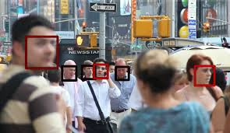

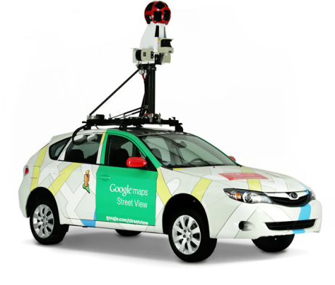



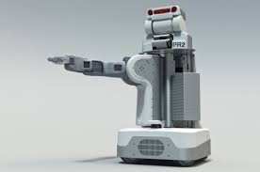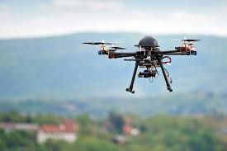

|  |  |  |  |
| --- | --- | --- | --- |
| CS475 Computer Vision | | | |
| Course Code: | CS-475 | **Semester:** |  |
| Credit Hours: | 3+0 | **Prerequisite Codes:** | Linear Algebra  Numerical Analysis |
| Instructor: | Wajahat Hussain | **Class:** |  |
| Office: | SEECS 218 | **Telephone:** |  |
| Lecture Days: |  | **E-mail:** | wajahat.hussain@seecs.edu.pk |
| Class Room: |  | **Consulting Hours:** |  |
| Lab Engineer: | N/A | **Lab Engineer Email:** | N/A |
| Knowledge Group: | CS Core | **Updates on LMS:** | After every lecture |

|  |  |
| --- | --- |
| Course Description: | |
|  | About 50% of the brain area is activated when eyes are working. This indicates that path to unlocking human intelligence is perhaps related to visual processing. How do humans manage to detect objects of different sizes and from different views? How do we manage to exist in a 3D world while perceiving only 2D images with our eyes? This course is about learning the basics of visual processing related to 3D scene modelling from single and multiple views. These concepts will form the basis of various computer vision applications related to surveillance, robotics and medical image processing etc. |

|  |  |
| --- | --- |
| Course Description: | |
|  | With a single glance a human interprets the entire scene. How many objects are present in the scene and where they are located? Which person is present in the scene? What will happen next? However, computers lack this capability. We have seen only face detectors so far working in our mobile phones? What is the challenge in understanding the 3D scene, i.e., the identity, the location and the size of the objects present in the scene. In this course we will introduce the basic concepts related to 3D scene modelling from single view and multiple views. |

|  |
| --- |
| Course Learning Outcomes: |
| |  |  |  |  | | --- | --- | --- | --- | | **CLO** | **Description**  After the completion of the course the students will be able to: | **BT**  **Level** | **PLOs** | | 1. | **Understand** the single view & multiple view geometry concepts | C2 | 1 | | 2. | **Understand** the robust estimation techniques | C2 | 1 | | 3. | **Implement** Computer Vision algorithms | C3 | 3 | |

|  |
| --- |
| Mapping of CLOs to Program Learning Outcomes |
| |  |  |  |  | | --- | --- | --- | --- | | **PLOs/CLOs** | **CLO1** | **CLO2** | **CLO3** | | PLO 1 (Engineering Knowledge) |  |  | √ | | PLO 2 (Problem Analysis) | √ | √ |  | | PLO 3 (Design/Development of Solutions) |  |  |  | | PLO 4 (Investigation) |  |  |  | | PLO 5 (Modern tool usage) |  |  |  | | PLO 6 (The Engineer and Society) |  |  |  | | PLO 7 (Environment and Sustainability) |  |  |  | | PLO 8 (Ethics) |  |  |  | | PLO 9 (Individual and Team Work) |  |  |  | | PLO 10 (Communication) |  |  |  | | PLO 11 (Project Management) |  |  |  | | PLO 12 (Lifelong Learning) |  |  |  | |

|  |
| --- |
| Mapping of CLOs to Assessment Modules |
| |  |  |  |  | | --- | --- | --- | --- | | **Assessments/CLOs** | **CLO1** | **CLO2** | **CLO3** | | Quizzes: 10% of the theory part | √ | √ | √ | | Assignments: 10% of the theory part | √ | √ | √ | | OHTs: 30% of the theory part | √ | √ | √ | | Project 10% |  |  | √ | | End Semester Exam:40% of theory part | √ | √ | √ | |

|  |  |
| --- | --- |
| Books: | |
| Text Book: | 1. Multiple View Geometry In Computer Vision by Richard Hartley and Andrew Zisserman  2. Lecture Notes  3. Programming Computer Vision with Python by Jan Erik Solem  4. Udacity online course (<https://www.udacity.com/course/introduction-to-computer-vision--ud810>)  <https://docs.google.com/spreadsheets/d/1ecUGIyhYOfQPi3HPXb-7NndrLgpX_zgkwsqzfqHPaus/pubhtml> |

|  |  |  |  |  |  |
| --- | --- | --- | --- | --- | --- |
| Lecture Breakdown: | | | | | |
|  | **Week No.** | | **Topics** | **Sections** | **Remarks** |
|  | 1 | Why Computer Vision? The State of the art in Computer Vision. | | CLO 1 |  |
|  | 2 | Image Processing: Filtering | | CLO 1 |  |
|  | 3 | Camera Model: How the 2D image is formed from the 3D world?  Homogenous Transform | | CLO 1 |  |
|  | 4 | Transformations in 2D: Editing the images | | CLO 1 |  |
|  | 5 | Homography: How to view an image from a different angle automatically  Image Stitching: Making a bigger picture from smaller pictures | | CLO 1 |  |
|  | **6** | **OHT-1** | | | |
|  | 7 | Transformations in 3D | | CLO 1 |  |
|  | 8 | Stereo Geometry: Making 3D model from two or more views | | CLO 1 |  |
|  | 9 | Fundamental Matrix | | CLO 1 |  |
|  | 10 | SIFT & SURF Descriptors: How to find an object appearing at different sizes? | | CLO 2 |  |
|  | 11 | RANSAC: How to fit a line if there are noisy points? | | CLO 2 |  |
|  | **12** | **OHT-2** | | | |
|  | 13 | Gradient Descent Algorithm | | CLO 2 |  |
|  | 14 | Single View Geometry: Vanishing Points  Single View Geometry: Converting a single image into a 3D model? Really? | | CLO 1 |  |
|  | 15 | Implementation In Python: Making a startup application | | CLO 3 |  |
|  | 16 | Discussion on Research Paper and Semester Project | | CLO 3 |  |
|  | 17 | Misc | |  |  |
|  | 18 | Week 18: ESE | |  |  |

|  |  |
| --- | --- |
| Tools / Software Requirement: | |
|  | * MATLAB (for programming assignments) * Python |

|  |  |
| --- | --- |
| Grading Policy: | |
| Quiz Policy: | The quizzes will be unannounced and normally last for ten minutes. The question framed is to test the concepts involved in last few lectures. Number of quizzes that will be used for evaluation is at the instructor’s discretion. |
| Assignment Policy: | In order to develop comprehensive understanding of the subject, assignments will be given. Late assignments will not be accepted / graded. All assignments will count towards the total (No ‘best-of’ policy). The students are advised to do the assignment themselves. Copying of assignments is highly discouraged and violations will be dealt with severely by referring any occurrences to the disciplinary committee. The questions in the assignment are meant to be challenging to give students confidence and extensive knowledge about the subject matter and enable them to prepare for the exams. **Note that for programming assignments viva will be conducted. The grading will be mainly based on the viva performance.** |
| Plagiarism: | NUST maintains a zero tolerance policy towards plagiarism. While collaboration in this course is highly encouraged, you must ensure that you do not claim other people’s work/ ideas as your own. Plagiarism occurs when the words, ideas, assertions, theories, figures, images, programming codes of others are presented as your own work. You must cite and acknowledge all sources of information in your assignments. Failing to comply with the NUST plagiarism policy will lead to strict penalties including zero marks in assignments and referral to the academic coordination office for disciplinary action. |

How a look at the following videos:

[Using a video to make a 3D model](https://www.youtube.com/watch?v=Df9WhgibCQA)

[3D modelling from Cameras](https://www.youtube.com/watch?v=Qe10ExwzCqk)